PART 3- ASSIGNMENT-2

Render HTML Pages (Web Documents) on to the server

Create a folder on desktop with a new file app.py to render html pages on to the server

Now create a folder named “templates’ where all the html files are stored and .the server searches of web documents in templates folder

Now create a html page called index inside templates older.

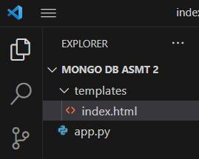

Now write the code into index.html

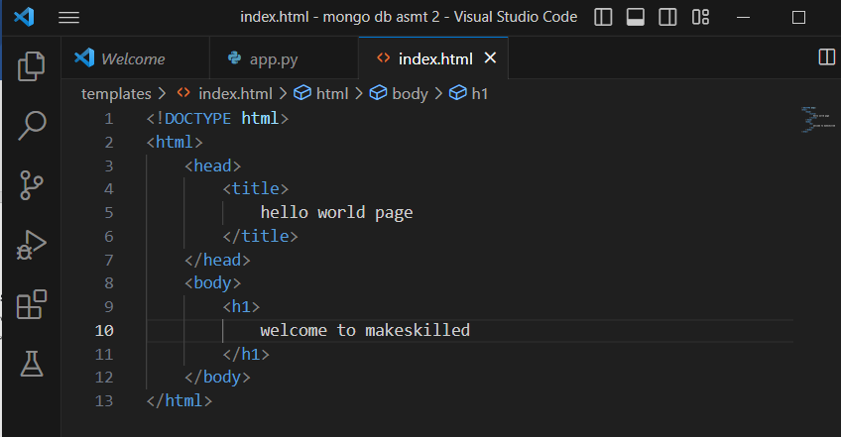

Now writing the code into app.py

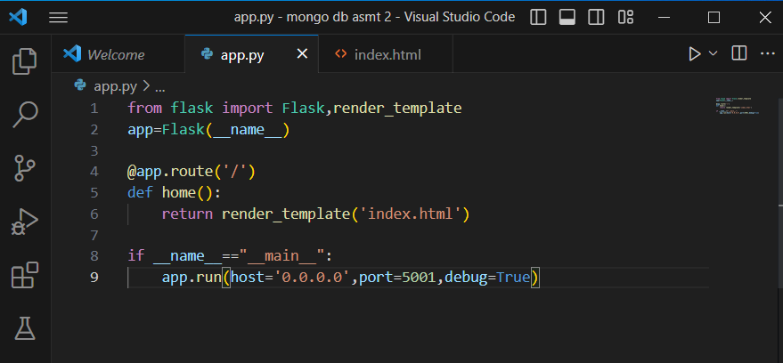

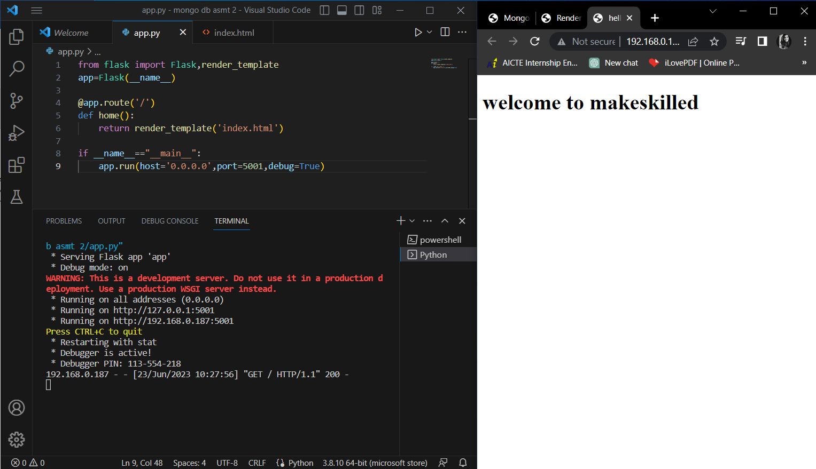

There is a need to check the spelling of templates folder and that index.html is placed inside templates folder only

After running the program follow the link : <http://192.168.0.187:5001> and it is redirected to the rendering of webpage in front end.